<http://www.youtube.com/watch?v=g-UcnUWdBjc>

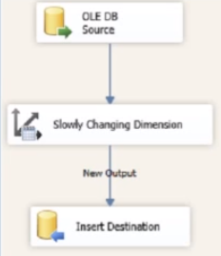

Source:

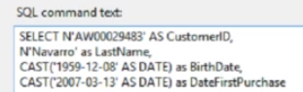

This is the first row of inofmration actually, and we are trying to insert the same data into DimCustomer using **CustomerAlternateKey**

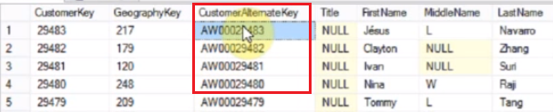

* Set the Table : DimCustomer
* Set Input field
* Set Type of key

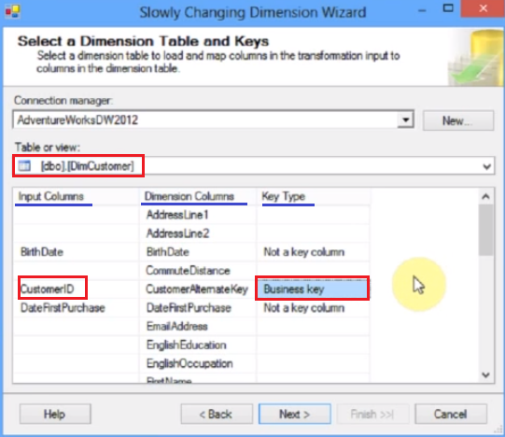

Click Next and include 3 fields: **BirthDate, DateFirstPurchase, LastName.** Set all type **Fixed Attribute**

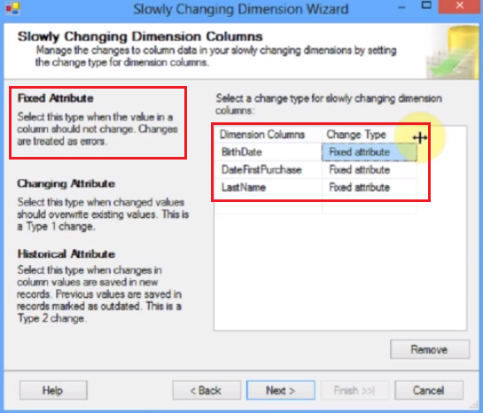

Click next

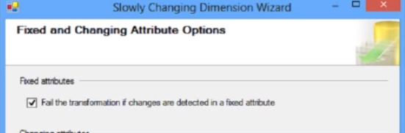

It will run without inserting, because is type 0 and the data in the source is the same as in the destination

If we change any value in the source, the process will stop, to avoid that change

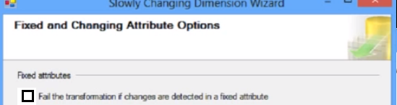

Which means, don’t fail if you find that the data has changed